SIMATS ENGINEERING
ASSESSMENT TOOL 2: Logic Reasoning & Mapping Exercise
COURSE NAME: ARTIFICIAL INTELLIGENCE COURSE CODE: MLA01
AND EXPERT SYSTEMS

COURSE OUTCOME COVERED
CO3: Implement propositional and first-order logic using resolution, unification, and inference techniques for knowledge representation and reasoning.(BTL 3)
Assessment Tool Weightage: 15%

Total Marks: 100 Time: 60 Mins
No. of Questions: 5
Annexure A
Logic Reasoning & Mapping Exercise

Code of Conduct:

I Uppu Sye Kumar/192325121 (Name / Reg No) certify that this submission is my original work and that I have adhered to the guidelines specified for this assessment. I understand that any violation of academic integrity rules will result in disciplinary action.
Signature of the student: U.SyeKumar

Criterion | Weightag e | Marks Obtained
1. Problem Analysis and Knowledge Identification | 15%
2. Logical Representation and Mapping | 20%
3. Predicates, Variables, Constants and Quantifiers | 15%
4. Logical Connectives and Formula Construction | 10%
5. Inference and Logical Reasoning | 15%
6. Unification and Substitution | 10%
7. Resolution and Proof Construction | 10%
8. Mapping Diagram / Clarity and Presentation | 5%
Total | 100%

ANSWER ANY ONE OF THE FOLLOWING

Q.No | Use Case Scenario
1 | Smart Healthcare  Diagnosis |  | A hospital uses an AI system to identify possible diseases from patient symptoms. Ravi has fever, cough, and body pain. Patients with fever and cough may have flu. Patients with flu and body pain may have viral infection. Patients with viral infection require medical attention.  Tasks:  - Identify facts, entities, predicates, variables, and constants.  - Represent the knowledge using Propositional Logic.  - Represent the knowledge using FOL with suitable quantifiers.  - Perform unification for two relevant predicates.  - Apply resolution to prove whether Ravi has a viral infection.  - Show the complete inference sequence and final conclusion.
2 | Student  Advising | Academic | A university AI system recommends academic support based on attendance and examination performance. Priya has attendance below 75% and has failed two courses. Students with low attendance require attendance counseling. Students who fail two or more courses require academic counseling. Students requiring both types of counseling need academic support.  Tasks:  - Identify the knowledge components.  - Convert the statements into Propositional Logic.  - Develop FOL representations using predicates and quantifiers.  - Identify suitable substitutions and perform unification.  - Use resolution to prove whether Priya requires academic support.  - Explain the reasoning steps leading to the conclusion.
3 | Intelligent Loan  Approval |  | A bank wants to use an AI knowledge-based system for preliminary loan approval. Arun has stable employment, sufficient income, a high credit score, and good repayment history. Customers with stable employment and sufficient income qualify for preliminary approval. Customers with a high credit score and preliminary approval are classified as low-risk. Low-risk customers with good repayment history can be recommended for loan approval.  Tasks:  - Identify entities, facts, predicates, and rules.  - Map the scenario into Propositional Logic.  - Represent the rules using FOL.
- Demonstrate unification and substitution.
- Use resolution to prove or disprove LoanApproved(Arun).
- Provide the final inference with justification.

4 | Vehicle Fault  Diagnosis |  | An automobile service center uses an expert system to diagnose vehicle faults. Car101 does not start and its headlights are dim. Vehicles that do not start and have dim headlights may have a battery problem. Vehicles with a battery problem require battery inspection. Vehicles requiring battery inspection are marked for service.  Tasks:  (i) Extract the facts and rules from the scenario. (ii) Represent them using Propositional Logic.  - Develop suitable FOL predicates and rules.  - Perform unification for the vehicle-related predicates.  - Apply resolution to determine whether Car101 has a battery problem. (vi) Derive whether Car101 should be marked for service and explain the inference.
5 | Cybersecurity  Threat Detection |  | An organization uses an AI system to identify cyber threats. User101 has five failed login attempts and logged in from an unusual location. Multiple failed login attempts indicate a possible brute-force attack. A brute-force attack combined with an unusual login location indicates suspicious activity. Suspicious activity combined with unauthorized access to confidential files indicates a possible security breach.  Tasks:  - Identify the facts, entities, predicates, and rules.  - Map the knowledge into Propositional Logic.  - Represent the rules using FOL.  - Demonstrate unification and substitution.  - Apply resolution to determine whether User101 is involved in a possible security breach.  - Present the complete reasoning chain and final inference.

LOGICAL REASONING AND MAPPING EXERCISE
Intelligent Loan Approval System

1. Introduction
This exercise demonstrates how logical reasoning and knowledge mapping can be applied to an Intelligent Loan Approval System. The main objective is to convert real-world loan information into entities, predicates, facts and rules, and then use symbolic inference to derive a justified conclusion.
The central query is:
LoanApproved(Arun) ?
The system demonstrates knowledge representation, unification, substitution, forward chaining, backward chaining and resolution. The loan domain is the application scenario; the primary focus is the logical mapping and reasoning process.

2. Objective of the Exercise
- Identify entities, facts, predicates and logical rules.
- Map natural-language statements to formal predicates.
- Represent the knowledge base using First-Order Logic.
- Demonstrate unification and substitution.
- Apply forward chaining from facts to a conclusion.
- Apply backward chaining from the query to supporting facts.
- Use resolution to prove a query by contradiction.
- Explain how knowledge engineering supports rule maintenance.

3. Problem Statement
A bank wants to determine whether a customer is eligible for a loan. The knowledge base contains information about income, credit score, employment, existing loans, repayment history, debt and default history.
- Arun has a stable job.
- Arun has a high credit score.
- Arun has sufficient income.
- Arun has good repayment history.
- Arun has no payment default.
- Arun has an existing loan but an acceptable debt level.
- Customers with stable employment and sufficient income receive preliminary approval.
- Customers with high credit scores and good repayment history are low-risk.
- Low-risk customers with preliminary approval can be recommended.
- A recommended customer with acceptable debt and no default can be approved.

4. Entities and Variables
The main entity is Arun. A variable x is used to represent any customer.
Entity:
Arun
Variable:
x
Example:
StableJob(x) → any customer x has a stable job
StableJob(Arun) → Arun has a stable job

5. Predicate Mapping
Natural-language knowledge | Predicate | Type
Arun has a stable job | StableJob(Arun) | Fact
Arun has a high credit score | HighCredit(Arun) | Fact
Arun has sufficient income | SufficientIncome(Arun) | Fact
Arun has good repayment history | GoodRepayment(Arun) | Fact
Arun has an existing loan | ExistingLoan(Arun) | Fact
Arun has no default | NoDefault(Arun) | Fact
Arun has valid employment | ValidEmployment(Arun) | Fact
Arun has acceptable debt | AcceptableDebt(Arun) | Fact
Arun has valid documents | ValidDocuments(Arun) | Fact
Arun is preliminarily approved | PreliminaryApproval(Arun) | Derived
Arun is low-risk | LowRisk(Arun) | Derived
Arun is recommended | LoanRecommended(Arun) | Derived
Arun is approved | LoanApproved(Arun) | Final derived

6. Knowledge Base: Facts
F1: StableJob(Arun)
F2: HighCredit(Arun)
F3: SufficientIncome(Arun)
F4: GoodRepayment(Arun)
F5: ExistingLoan(Arun)
F6: NoDefault(Arun)
F7: ValidEmployment(Arun)
F8: AcceptableDebt(Arun)
F9: ValidDocuments(Arun)
F10: BasicEligible(Arun)

7. Knowledge Base: Rules

R1 – Preliminary approval
StableJob(x) ∧ SufficientIncome(x) → PreliminaryApproval(x)

R2 – Low risk
HighCredit(x) ∧ GoodRepayment(x) → LowRisk(x)

R3 – Reliability
GoodRepayment(x) ∧ NoDefault(x) → ReliableCustomer(x)

R4 – Debt verification
ExistingLoan(x) ∧ AcceptableDebt(x) → DebtAcceptable(x)

R5 – Employment verification
ValidEmployment(x) ∧ StableJob(x) → EmploymentVerified(x)

R6 – Basic eligibility
ValidDocuments(x) ∧ EmploymentVerified(x) → BasicEligible(x)

R7 – Loan recommendation
PreliminaryApproval(x) ∧ LowRisk(x) → LoanRecommended(x)

R8 – Final approval
LoanRecommended(x) ∧ DebtAcceptable(x) ∧ NoDefault(x) → LoanApproved(x)

8. Knowledge Mapping Diagram
The diagram maps customer facts through intermediate logical conclusions to the final approval decision.
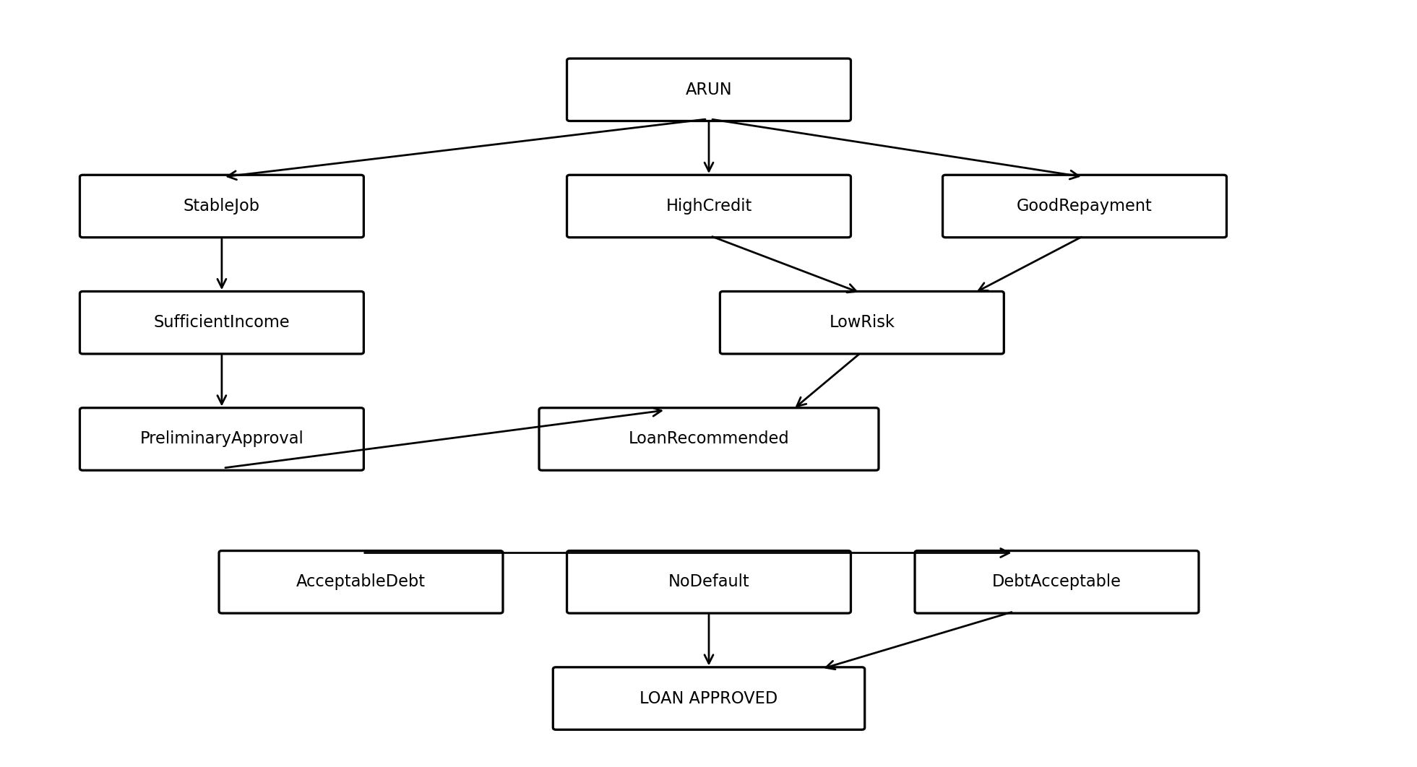
Figure 1: Knowledge and predicate mapping for Arun.

9. First-Order Logic Representation
Facts:
StableJob(Arun)
HighCredit(Arun)
SufficientIncome(Arun)
GoodRepayment(Arun)
ExistingLoan(Arun)
NoDefault(Arun)
ValidEmployment(Arun)
AcceptableDebt(Arun)
ValidDocuments(Arun)
BasicEligible(Arun)
General rules:
∀x [StableJob(x) ∧ SufficientIncome(x) → PreliminaryApproval(x)]
∀x [HighCredit(x) ∧ GoodRepayment(x) → LowRisk(x)]
∀x [GoodRepayment(x) ∧ NoDefault(x) → ReliableCustomer(x)]
∀x [ExistingLoan(x) ∧ AcceptableDebt(x) → DebtAcceptable(x)]
∀x [ValidEmployment(x) ∧ StableJob(x) → EmploymentVerified(x)]
∀x [ValidDocuments(x) ∧ EmploymentVerified(x) → BasicEligible(x)]
∀x [PreliminaryApproval(x) ∧ LowRisk(x) → LoanRecommended(x)]
∀x [LoanRecommended(x) ∧ DebtAcceptable(x) ∧ NoDefault(x)
→ LoanApproved(x)]
Here, ∀x means “for every customer x.”

10. Unification and Substitution
Unification finds substitutions that make two logical expressions identical. Substitution replaces a variable with a constant or another term.
Expression 1:
StableJob(x)
Expression 2:
StableJob(Arun)
Most General Unifier (MGU):
{x / Arun}
After substitution:
StableJob(x) → StableJob(Arun)
Multiple-condition example:
Rule:
HighCredit(x) ∧ GoodRepayment(x) → LowRisk(x)
Facts:
HighCredit(Arun)
GoodRepayment(Arun)
Substitution:
{x / Arun}
Result:
LowRisk(Arun)

11. Forward Chaining
Forward chaining is data-driven reasoning. It starts with known facts, applies rules whose conditions are satisfied, adds the derived facts to the knowledge base, and continues until the target is reached.

Step 1 – R1
StableJob(Arun) ∧ SufficientIncome(Arun) → PreliminaryApproval(Arun)

Step 2 – R2
HighCredit(Arun) ∧ GoodRepayment(Arun) → LowRisk(Arun)

Step 3 – R3
GoodRepayment(Arun) ∧ NoDefault(Arun) → ReliableCustomer(Arun)

Step 4 – R4
ExistingLoan(Arun) ∧ AcceptableDebt(Arun) → DebtAcceptable(Arun)

Step 5 – R5
ValidEmployment(Arun) ∧ StableJob(Arun) → EmploymentVerified(Arun)

Step 6 – R6
ValidDocuments(Arun) ∧ EmploymentVerified(Arun) → BasicEligible(Arun)

Step 7 – R7
PreliminaryApproval(Arun) ∧ LowRisk(Arun) → LoanRecommended(Arun)

Step 8 – R8
LoanRecommended(Arun) ∧ DebtAcceptable(Arun) ∧ NoDefault(Arun) → LoanApproved(Arun)
Forward-chaining conclusion:
Facts
↓
PreliminaryApproval(Arun)
↓
LowRisk(Arun)
↓
LoanRecommended(Arun)
↓
DebtAcceptable(Arun) + NoDefault(Arun)
↓
LoanApproved(Arun)

12. Forward Chaining Summary Table
Step | Rule | New fact
1 | Step 1 – R1 | PreliminaryApproval(Arun)
2 | Step 2 – R2 | LowRisk(Arun)
3 | Step 3 – R3 | ReliableCustomer(Arun)
4 | Step 4 – R4 | DebtAcceptable(Arun)
5 | Step 5 – R5 | EmploymentVerified(Arun)
6 | Step 6 – R6 | BasicEligible(Arun)
7 | Step 7 – R7 | LoanRecommended(Arun)
8 | Step 8 – R8 | LoanApproved(Arun)

13. Forward and Backward Reasoning Diagram
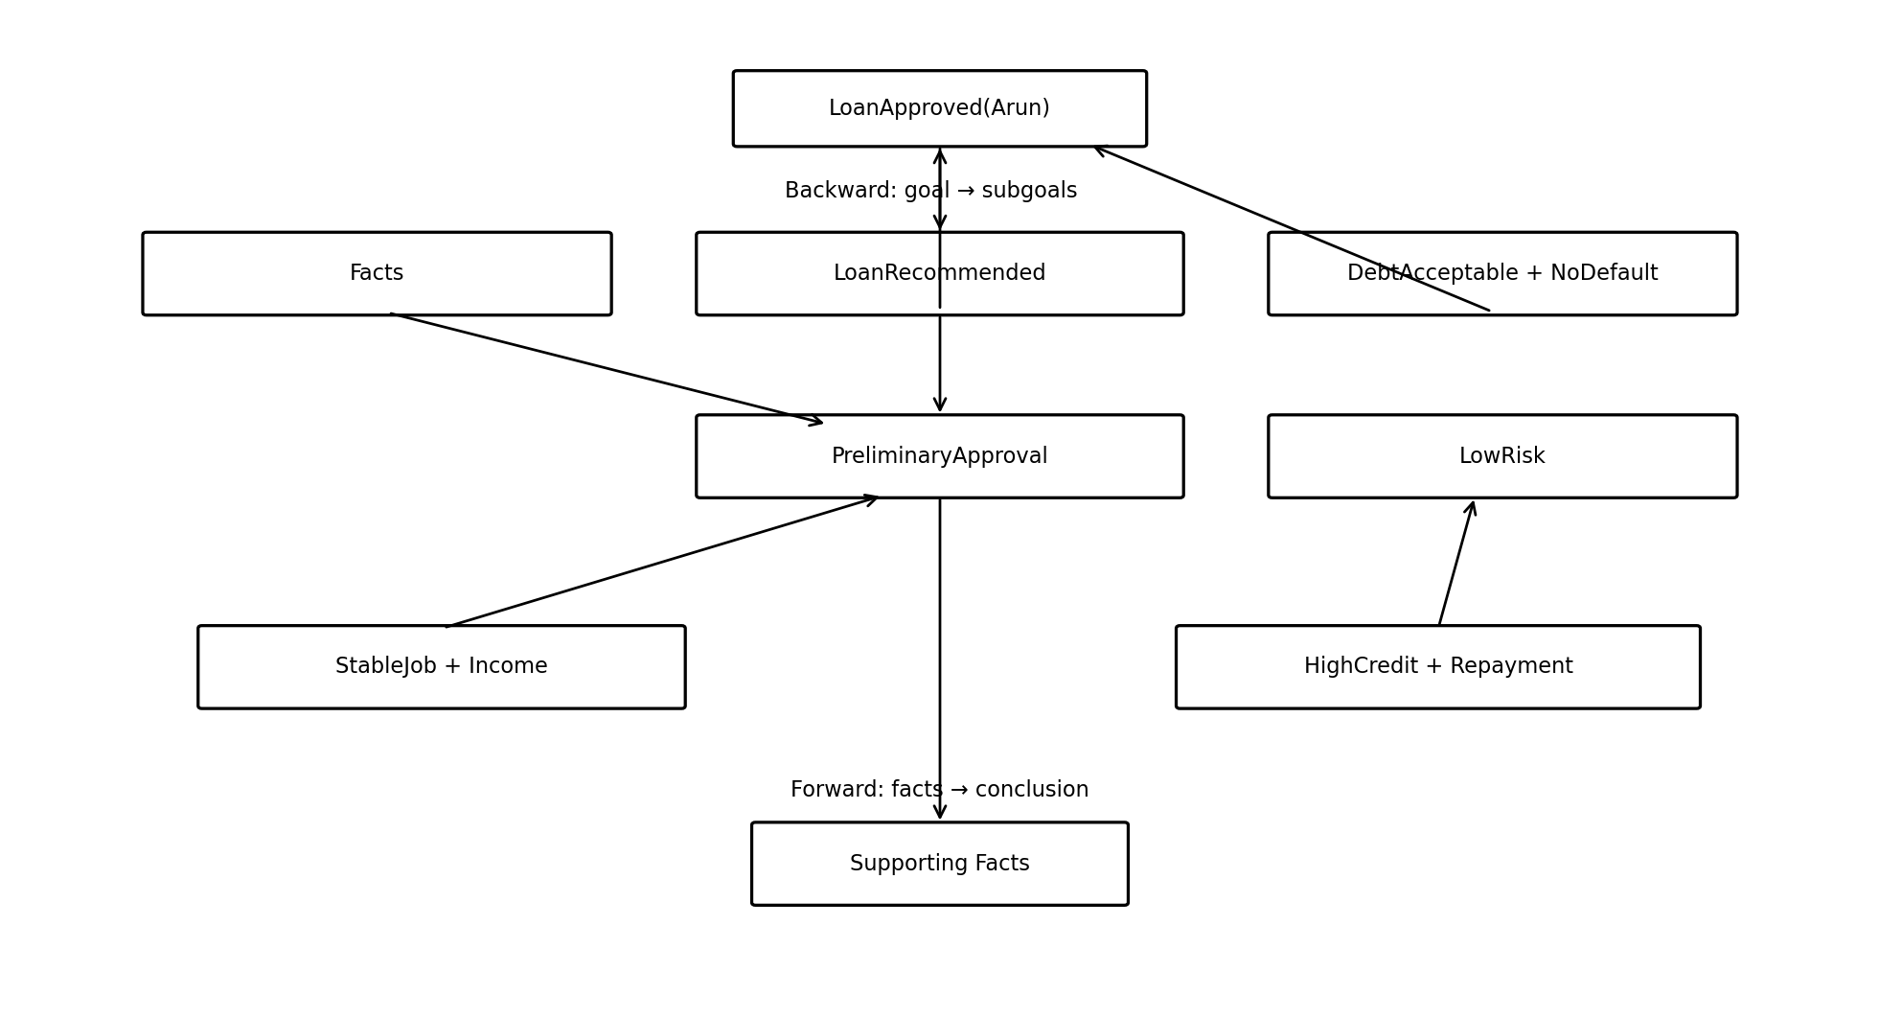
Figure 2: Forward and backward reasoning paths.

14. Backward Chaining
Backward chaining is goal-driven reasoning. It starts with the query and works backward to identify the rules and facts required to prove it.
Query: LoanApproved(Arun)

14.1 Goal Expansion
R8:
LoanRecommended(x) ∧ DebtAcceptable(x) ∧ NoDefault(x)
→ LoanApproved(x)
Substitute x = Arun.
Required:
LoanRecommended(Arun)
DebtAcceptable(Arun)
NoDefault(Arun)

14.2 Proving LoanRecommended
R7:
PreliminaryApproval(x) ∧ LowRisk(x)
→ LoanRecommended(x)
Required:
PreliminaryApproval(Arun)
LowRisk(Arun)

14.3 Proving PreliminaryApproval
R1:
StableJob(x) ∧ SufficientIncome(x)
→ PreliminaryApproval(x)
Facts:
StableJob(Arun)
SufficientIncome(Arun)
Therefore:
PreliminaryApproval(Arun)

14.4 Proving LowRisk
R2:
HighCredit(x) ∧ GoodRepayment(x)
→ LowRisk(x)
Facts:
HighCredit(Arun)
GoodRepayment(Arun)
Therefore:
LowRisk(Arun)

14.5 Proving DebtAcceptable
R4:
ExistingLoan(x) ∧ AcceptableDebt(x)
→ DebtAcceptable(x)
Facts:
ExistingLoan(Arun)
AcceptableDebt(Arun)
Therefore:
DebtAcceptable(Arun)

14.6 Proving NoDefault
NoDefault(Arun) is a direct fact.
Therefore:
NoDefault(Arun) = TRUE
All subgoals are satisfied, so LoanApproved(Arun) is proved.

15. Backward-Chaining Reasoning Tree
LoanApproved(Arun)
|
| R8
↓
LoanRecommended(Arun)
/ \
/ \
↓ ↓
PreliminaryApproval LowRisk
| |
R1 R2
/ \ / \
↓ ↓ ↓ ↓
StableJob Income HighCredit Repayment
DebtAcceptable(Arun)
|
R4
/ \
↓ ↓
ExistingLoan AcceptableDebt
NoDefault(Arun)
|
FACT

16. Resolution
Resolution proves a query by contradiction. The query is negated temporarily; if the knowledge base derives the original query, both the query and its negation occur, producing a contradiction.

16.1 Clause Form Example
Rule:
StableJob(x) ∧ SufficientIncome(x) → PreliminaryApproval(x)
Clause form:
¬StableJob(x) ∨ ¬SufficientIncome(x) ∨ PreliminaryApproval(x)

16.2 Resolution Steps
Known facts:
StableJob(Arun)
SufficientIncome(Arun)
Resolve with the clause:
¬StableJob(Arun) ∨ ¬SufficientIncome(Arun)
∨ PreliminaryApproval(Arun)
Result:
PreliminaryApproval(Arun)
Continue through the approval rules:
PreliminaryApproval(Arun) + LowRisk(Arun)
→ LoanRecommended(Arun)
LoanRecommended(Arun)
+ DebtAcceptable(Arun)
+ NoDefault(Arun)
→ LoanApproved(Arun)

16.3 Proof by Contradiction
Query:
LoanApproved(Arun)
Assume the negation:
¬LoanApproved(Arun)
Knowledge base derives:
LoanApproved(Arun)
Therefore:
LoanApproved(Arun) ∧ ¬LoanApproved(Arun)
Contradiction.
Conclusion:
KB ⊨ LoanApproved(Arun)

17. Resolution Proof Diagram
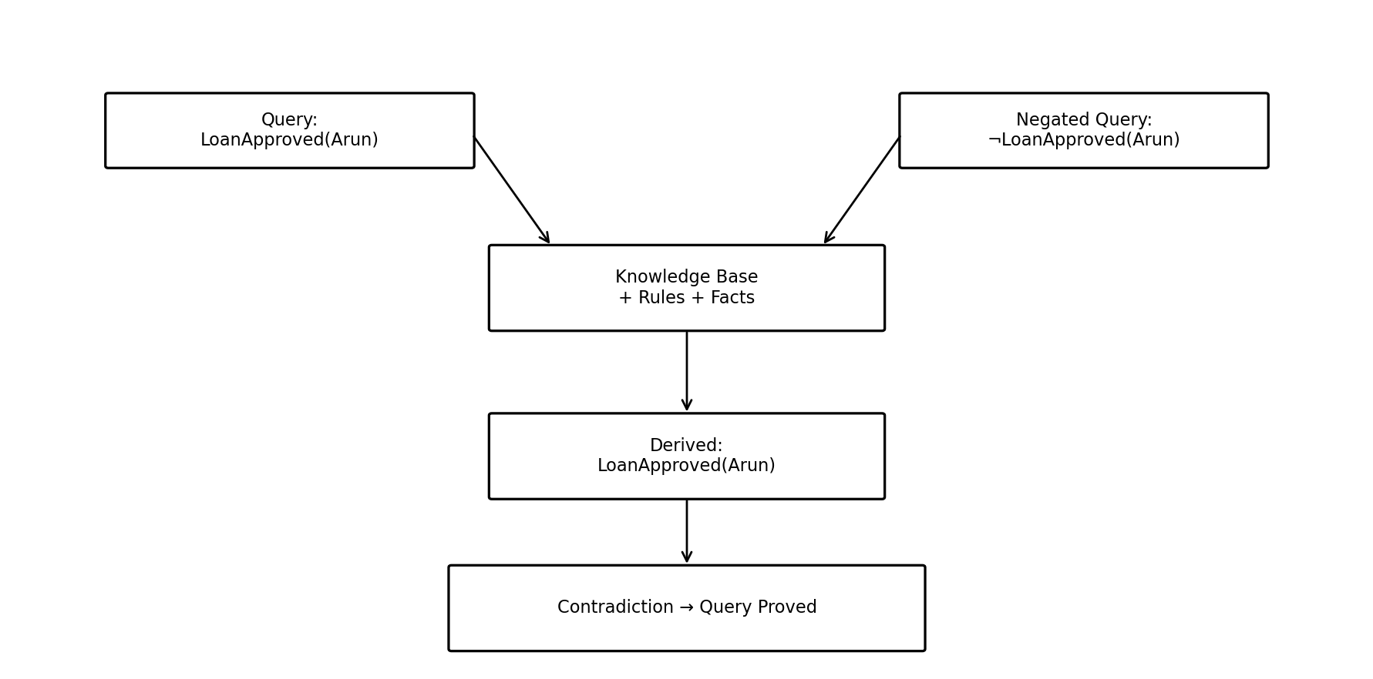
Figure 3: Resolution proof by contradiction.

18. Comparison of Reasoning Techniques
Technique | Direction | Starts with | Main purpose
Unification | Matching | Logical expressions | Find compatible substitutions
Substitution | Replacement | Variables | Replace variables with constants/terms
Forward chaining | Forward | Known facts | Derive new facts and conclusions
Backward chaining | Backward | Goal/query | Find facts needed to prove the goal
Resolution | Contradiction | Query + negation | Prove or disprove a statement

19. Why This Is a Logical Reasoning and Mapping Exercise
The focus is symbolic reasoning rather than statistical prediction. The system does not calculate a probability of approval. It checks whether facts satisfy logical rules.
Natural-language statement
↓
Predicate
↓
Fact
↓
Rule matching
↓
Unification / substitution
↓
Inference
↓
New fact
↓
Final conclusion
For example, the statement 'Arun has a stable job' becomes StableJob(Arun). When combined with SufficientIncome(Arun) and Rule R1, the system derives PreliminaryApproval(Arun).

20. Knowledge Engineering Process

Knowledge acquisition
Collect loan eligibility knowledge from bank policies, loan officers, credit analysts and regulations.

Knowledge representation
Convert natural-language knowledge into entities, predicates, facts and rules.

Knowledge validation
Check whether rules are logically correct and acceptable to domain experts.

Knowledge organization
Group rules into employment, income, credit, repayment, debt, risk and approval categories.

Knowledge updating
Modify or add rules when loan policies change.

Conflict detection
Identify rules that could lead to inconsistent conclusions and add priorities or additional conditions.

Explainability
Maintain the inference path so the system can explain why a conclusion was reached.

21. How Knowledge Engineering Helps Maintain Loan Rules
Benefit | Explanation
Easy modification | Bank policy changes can be implemented by changing the relevant rule.
Consistency | The same logical rules can be applied to every customer.
Explainability | The system can show the facts and rules used to reach approval.
Reusability | General rules can be applied to many customers.
Testing | Individual rules can be tested independently.
Transparency | The reasoning chain is visible instead of being a black-box decision.
Reduced manual effort | The inference engine can perform repetitive logical checks automatically.

22. Complete Logical Proof
1. StableJob(Arun) FACT
2. SufficientIncome(Arun) FACT
3. HighCredit(Arun) FACT
4. GoodRepayment(Arun) FACT
5. ExistingLoan(Arun) FACT
6. AcceptableDebt(Arun) FACT
7. NoDefault(Arun) FACT
8. StableJob(Arun) ∧ SufficientIncome(Arun)
→ PreliminaryApproval(Arun)
9. HighCredit(Arun) ∧ GoodRepayment(Arun)
→ LowRisk(Arun)
10. PreliminaryApproval(Arun) ∧ LowRisk(Arun)
→ LoanRecommended(Arun)
11. ExistingLoan(Arun) ∧ AcceptableDebt(Arun)
→ DebtAcceptable(Arun)
12. LoanRecommended(Arun)
∧ DebtAcceptable(Arun)
∧ NoDefault(Arun)
→ LoanApproved(Arun)

23. Final Conclusion
The Intelligent Loan Approval System successfully demonstrates logical reasoning and mapping. Real-world loan statements are mapped to predicates and facts. Logical rules are then applied using unification and substitution. Forward chaining derives the approval from the available facts, while backward chaining starts from LoanApproved(Arun) and verifies the required subgoals. Resolution proves the query by contradiction.
StableJob + SufficientIncome
↓
PreliminaryApproval
HighCredit + GoodRepayment
↓
LowRisk
PreliminaryApproval + LowRisk
↓
LoanRecommended
LoanRecommended + DebtAcceptable + NoDefault
↓
╔══════════════════════════╗
║ LoanApproved(Arun) ║
║ TRUE ║
╚══════════════════════════╝
Therefore, LoanApproved(Arun) is logically entailed by the defined knowledge base. The exercise demonstrates how symbolic AI can transform natural-language knowledge into a structured logical map and use formal inference methods to reach a justified conclusion.

EVALUATION RUBRICS:

Criterion |  | Weightage  (%) | Excellent | Good | Average | Poor
Problem  Understanding  & Knowledge  Identification |  | 15% | 13–15% –  Clearly identifies entities, facts, relationships, assumptions, and reasoning requirements from the given scenario. | 10–12% –  Identifies most relevant knowledge with minor omissions. | 7–9% –  Identifies basic knowledge but misses several important elements. | 0–6% – Poor or  incorrect identification of the given knowledge.
Logical  Representation  & Mapping |  | 20% | 17–20% –  Accurately maps real-world statements into appropriate propositional and first-order logic representations. | 13–16% –  Provides mostly correct logical mappings with minor errors. | 9–12% –  Provides partial mappings with several logical errors. | 0–8% – Logical mapping is largely incorrect or missing.
Predicates,  Variables,  Constants  Quantifiers | & | 15% | 13–15% –  Correctly identifies and applies predicates, variables, constants, universal and  existential quantifiers. | 10–12% – Uses the  concepts correctly  with minor errors. | 7–9% –  Demonstrates partial understanding  with some  incorrect usage. | 0–6% – Concepts are incorrectly applied or missing.
Logical  Connectives &  Formula  Construction |  | 10% | 9–10% –  Correctly  applies AND,  OR, NOT,  implication, and equivalence to | 7–8% –  Mostly correct use  of connectives with minor errors. | 5–6% – Basic use of connectives but several errors occur. | 0–4% – Incorrect or incomplete  formula construction.
 |  |  | construct valid logical formulas.
Inference  Logical  Reasoning | & | 15% | 13–15% –  Performs accurate step-by-step reasoning and derives valid conclusions from the given knowledge. | 10–12% –  Reasoning is mostly correct with minor gaps. | 7–9% –  Provides partial reasoning with some incorrect conclusions. | 0–6% –  Reasoning is  incorrect,  unsupported, or missing.
Unification  Substitution | & | 10% | 9–10% –  Correctly identifies substitutions  and Most  General Unifier  (MGU) and applies them accurately. | 7–8% –  Correctly performs most unification  steps with minor errors. | 5–6% –  Demonstrates basic understanding but has several errors. | 0–4% – Unable to perform  unification correctly.
Resolution  Proof  Construction | / | 10% | 9–10% –  Correctly applies resolution and presents a clear, logically valid proof of the query. | 7–8% –  Resolution is mostly correct with minor errors. | 5–6% – Shows  partial understanding  but proof contains gaps. | 0–4% –  Resolution is incorrect or not demonstrated.
Clarity,  Mapping  Diagram  Presentation | & | 5% | 5% – Provides a clear,  well-organized mapping/logic diagram with  accurate  notation and  excellent presentation. | 4% –  Presentation is clear with minor formatting or diagram issues. | 3% – Basic  presentation  with limited clarity. | 0–2% – Poorly  organized,  unclear, or  incomplete presentation.

